Chia Chicken Nuggets

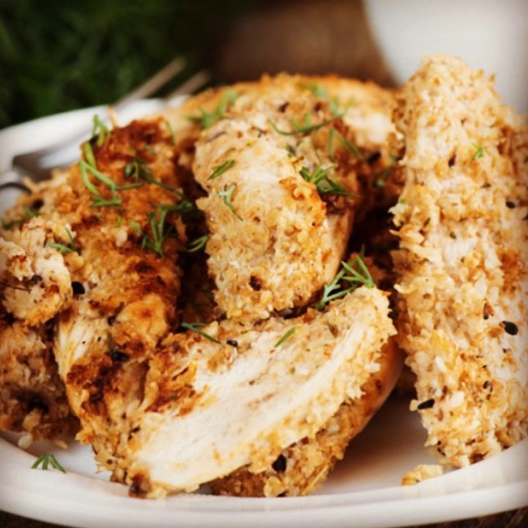
This lunchbox friendly recipe is a gluten-free version of store bought nuggets. Crumbed in chia and almond meal (or oats), and oven baked seals in the juices for a flavourful and tender chicken nugget.
Homemade nuggets allow you to control what goes in and can be adjusted to suit all tastes by swapping herbs, adding some heat from chilli or horseradish and swapping ingredients to cater for allergies and intolerances. The chia and nuts (or oats) provide extra fibre and the nuggets are prepared without the extra trans fats, sodium, refined carbohydrates, and other unidentifiable ingredients that have no place in a lunchbox.
So, if you or your kids need to remedy a nugget craving, give these guys a go. You will thank us for it!

Allergens:
Lactose Free Options | Gluten free | Vegetarian Options | Nut Free Options | Vegan Options | Low FODMAP Options | Dairy Free Options | Grain Free | Low Oxalate Options | Allergen Alert: Dairy, Nuts, Yoghurt

Recipe:
Family friendly | Freezable | Snack | Leftovers | Dinner | Lunch

Preparations time: 20mins
Baking time: 20 mins
Serves: 4

Ingredients
400g chicken breast fillets
1 cup natural yoghurt
1 clove garlic, minced or finely chopped

Coating:
2 tbsp chia seeds
½ cup almond meal or ground oats
1 tsp paprika (sweet or smoked)
1 tbsp fresh parsley, rosemary, thyme or oregano, finely chopped
1 tbsp finely grated parmesan
Sea salt
Pepper
Olive oil

Instructions
- Preheat oven to 180C and grease or line a baking tray.
- Slice the chicken into chunks (nuggets) or strips and set aside.
- In a bowl, combine the yoghurt and garlic and mix well. Set aside.
- In a separate bowl, mix together the chia seeds, almond meal or oats, paprika, herbs, Parmesan, salt and pepper.
- Add the chicken pieces to the yoghurt mixture and coat generously.
- Transfer the coated chicken to the chia mix and press the crumb down into the chicken to coat well.
- Gently place the coated chicken onto the prepared tray and drizzle with olive oil.
- Place the tray in the oven and cook for 15-20 mins, turning once, or until the crumb is golden brown and the chicken is cooked through.

Variations & Substitutions
Add some tomato puree to the yoghurt mix if using oregano for a pizza-flavoured nugget.
Add a little wasabi, horseradish or hot English mustard to the yoghurt mix for a kick of sinus-clearing heat for more adult palates.
Serve with a dip such as Green Hummus for a fun addition to lunchboxes or as an after school snack.
For a nut free option, coat with ground oats, sesame seeds or crushed seeds such as sunflower or pumpkin seeds.
For a vegetarian or vegan option, replace the chicken with vegetables such as cauliflower, zucchini. mushrooms or eggplant. For a vegan coating, omit the parmesan, or replace with nutritional yeast for a cheese-like flavour, and coat with unsweetened coconut or soy yoghurt.
For a lactose or dairy free option, omit the parmesan, or replace with nutritional yeast for a cheese-like flavour and coat with unsweetened coconut or soy yoghurt.
For a low amine option, replace the almond meal with ground oats and omit the paprika.
For a low FODMAP version, use a lactose free yoghurt and omit the garlic. Replace the almond meal with polenta or quinoa flakes, or with sesame seeds.

