Chicken and Pineapple Tacos

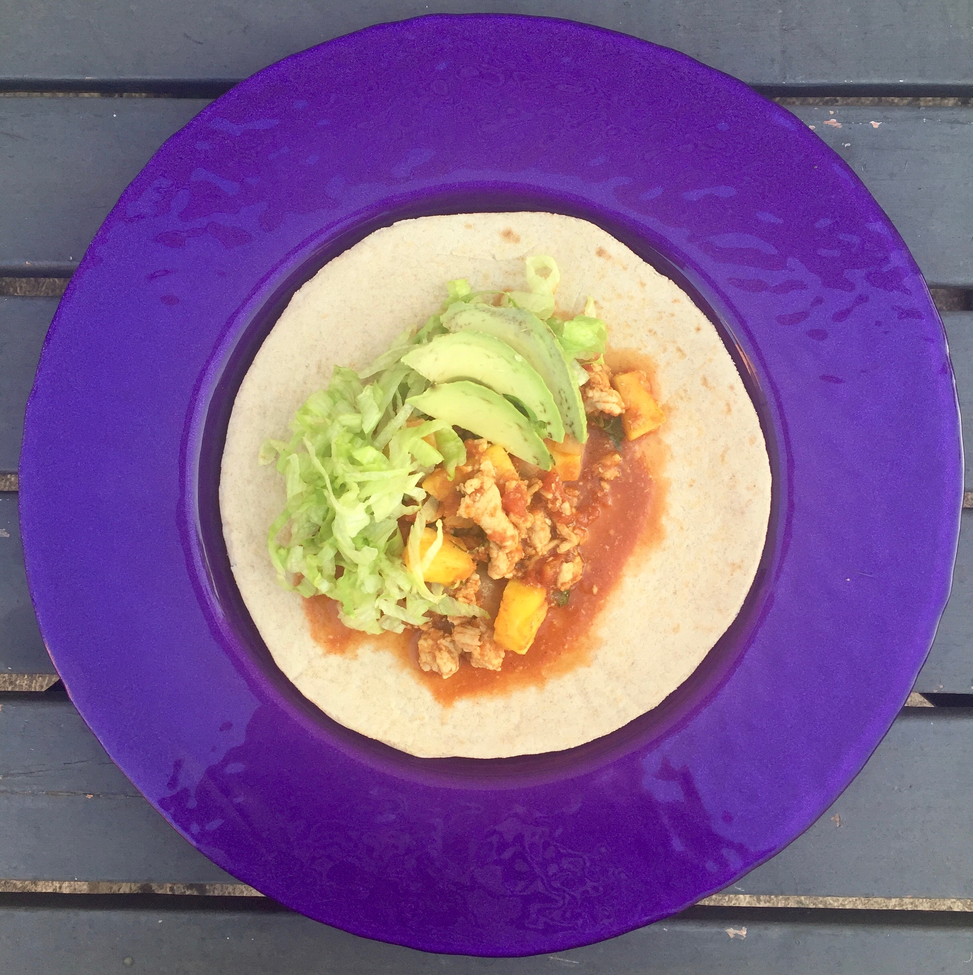
These Chicken and Pineapple Tacos tick all the boxes. Simple, delicious, healthy, colourful, freezable, great protein, healthy fats and dotted with sweet golden pineapple.

Pineapple is rich in vitamin C and bromelain, an enzyme found in the stem and core that has loads of health benefits. These two nutrients in particular are particularly interesting in terms of seasonal allergies such as hayfever and reducing symptoms of colds and flu making this a great dish all year round. The core can be a little fibrous and hard to chew in big chunks, so we like to remove the skin and slice the pineapple into quarters longways (with the cross cutting through the centre of the core), and then slicing up into smaller triangle shapes. This means that every portion gets a little bit of the core without the struggle.

The sweet and mild flavours of the pineapple and chicken make these tacos a hit with the kids. Try wrapping the leftover pineapple and chicken mix with a little avocado and lettuce in a sheet of rice paper that has been run under a tap to soften to make leftovers easier in lunchboxes.

Allergens:
Lactose Free | Gluten free | Vegetarian Options | Nut Free | Vegan Options | Low FODMAP Options | Egg Free | Dairy Free | Grain Free | Wheat Free | Soy Free | Seafood Free | Low Oxalate Options

Recipe:
Family friendly | Freezable | Leftovers | Dinner | Lunch

Preparations time: 10mins
Cooking time: 20 mins
Serves: 4-6

Ingredients
1 tbsp olive oil
1 brown onion, finely diced
1 tbsp smoked paprika
1 clove garlic
500g chicken mince
1 can chopped tomatoes
1 small pineapple, peeled and cut into chunks
1 capsicum, deseeded and cut into chunks
½ cup basil leaves, sliced
Salt and Pepper

To serve:
1 head Cos lettuce, washed and shredded
1 avocado sliced or mashed
Sturdy cabbage leaves / roasted vegetables / wholegrain wraps / quinoa / brown rice

Instructions
- Heat the oil in a large frying pan over medium heat, then add the onion and paprika, stirring until the onion has softened.
- Add the garlic and chicken, breaking up and stirring until just cooked.
- Stir through the tomatoes and bring to a simmer for 10 minutes.
- Add the pineapple and capsicum and cook for a further 5 minutes.
- Remove from the heat and stir through the basil leaves.
- Serve buffet style and either wrap the chicken mixture with some lettuce and avocado, or serve in a bowl.

Variations & Substitutions
Try wrapping the leftover pineapple and chicken mix with a little avocado and lettuce in a sheet of rice paper that has been run under a tap to soften to make leftovers easier in lunchboxes.
Try swapping the chicken for a white fish such as snapper or ling.
For a vegetarian or vegan option, swap the chicken for tofu or chickpeas.
For a low FODMAP option, omit the garlic and onion, and omit or limit the avocado to no more than 1-2 tsp. Add in 1 tbsp chopped chives with the basil.
For a low oxalate version, try swapping the tomatoes for a low oxalate vegetable stock or apple puree. Swap the basil for chives or coriander and serve with cabbage leaves.

